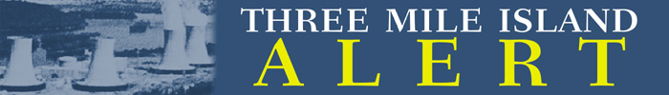
November 30, 2020

Three Mile Island Legal Melt Down: NRC Bypasses Hearing; Illegally Approves License Transfer and $900 Million to A Fictional Limited Liability Corporation

(Harrisburg) - TMI-Alert just received notice that the Three Mile Island (“TMI”) Unit-2license transfer could proceed from FirstEnergy to TMI-2 Solutions without a hearing. The illegal decree will transfer $900 million in ratepayer assets.

FirstEnergy, which currently holds the license, was recently implicated in a bribery scandal involving the Ohio nuclear bailout.

TMI-2 Solutions, the new owner, is a fictional limited liability corporation based in Utah with no assets.

The Nuclear Regulatory Commission (“NRC”) is fast-tracking the TMI icense transfer application without due process or a hearing. This tactic is illegal, and lets FirstEnergy off the hook for the cleanup of one the nation’s most radioactive sites.

Eric Epstein, Chairman of TMI-Alert (“TMIA”), filed a legal and timely Petition on April 15, 2020. The NRC has refused to act on the Petition. Mr. Epstein asked, “How can the NRC transfer TMI-2’s license - and $900 million - when there is a hearing request pending? This is illegal, and no different than a jury reaching a verdict without a trial. How can this happen in America?”

The NRC, in language reminiscent of Alice and Wonderland, stated, “The hearing, if granted would not be completed prior to the approval of the license transfer application."

It is also perplexing that the Department of Environmental Protection would sign off on this approach. The Department still has concerns about the availability of financial resources to adequately complete radiological decommissioning of TMI-2.

The Pennsylvania Public Utility Commission refused to get involved in the case involving ratepayer tariffs.

Despite decades of legal engagement relating to Three Mile Island, TMI-Alert, which is a party in good standing, was not consulted. The DEP, which withdrew from the case and is not a party, discussed the matter with the NRC on October 8, 2020.

Eric Epstein, Chairman of TMI-Alert said, “The NRC, in contravening the Atomic Energy Act, has silenced the public’s voice in a critical matter involving one of the most radioactive sites in America.”

