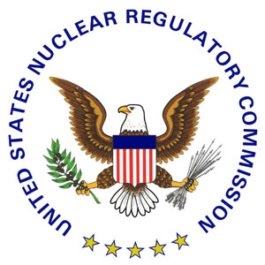 | NRC NEWS  U.S. NUCLEAR REGULATORY COMMISSION  Office of Public Affairs Telephone: 301/415-8200  Washington, D.C. 20555-0001  E-mail: opa.resource@nrc.gov  Site: http://www.nrc.gov
No. 09-146 | September 3, 2009

NRC CHAIRMAN TASKS STAFF TO EVALUATE
AGENCY ACTIVITIES ON BURIED PIPING AT NUCLEAR REACTORS

NRC Chairman Gregory B. Jaczko has tasked the agency’s technical staff to review the NRC’s approach for overseeing buried pipes given recent incidents of leaking buried pipes at several U.S. commercial nuclear power plants.

“Although they have not jeopardized public health and safety, leaks from buried pipes continue to occur and we need to assess the NRC’s and licensee’s efforts to prevent them,” Jaczko said. “The agency’s handling of these events has focused on each incident as it occurs, but we need to look at what we’re doing on a generic level to determine what additional actions may be necessary.”

The staff must provide the Commission an information paper in early December that explains both ongoing and planned generic activities that address leaks from buried piping. Chairman Jaczko also asked the staff to discuss actions or plans regarding:

- Evaluating the adequacy of NRC requirements for designing, inspecting and maintaining safety-related buried piping, including rules governing operating reactors, reactor license renewal and new reactor licensing;
- Evaluating the adequacy of American Society of Mechanical Engineers Code for designing, inspecting and maintaining safety-related buried piping;
- Evaluating how effective current rules and voluntary initiatives for designing, inspecting and maintaining all nuclear power plant buried piping are in ensuring public health and protecting the environment, and;
- Recommending any necessary revisions to existing regulations, requirements, practices or oversight regarding the integrity of buried piping.

Recent instances of leaks in buried pipes have primarily involved water containing elevated levels of tritium, a mildly radioactive isotope of hydrogen. The NRC continues to review how plants dealing with these leaks are using monitoring programs to confirm there is no significant effect on public health and safety and the environment.

A copy of the Chairman’s September 3 memorandum tasking the staff with this review will be available via the NRC web site at: www.nrc.gov . It will be located in the online electronic documents system known as ADAMS under Accession Number ML092460648.

###

News releases are available through a free listserv subscription at the following Web address: http://www.nrc.gov/public-involve/listserver.html. The NRC homepage at www.nrc.gov also offers a SUBSCRIBE link. E-mail notifications are sent to subscribers when news releases are posted to NRC's Web site.

