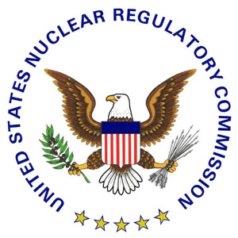 | NRC NEWS  U.S. NUCLEAR REGULATORY COMMISSION  Office of Public Affairs Telephone: 301/415-8200  Washington, D.C. 20555-0001  E-mail: opa.resource@nrc.gov  Site: http://www.nrc.gov
No. 09-183 | November 10, 2009

NRC MEETING NOV. 16 IN ROCKVILLE, MD., TO DISCUSS
NEW REACTOR CONSTRUCTION ASSESSMENT PROCESS

Nuclear Regulatory Commission staff will host a panel discussion in Rockville, Md., on Monday, Nov. 16, to discuss the agency’s process for assessing licensee performance during new reactor construction efforts.

The NRC will hold the meeting from 8:30 to 11:30 a.m. in the Bethesda North Marriott Hotel and Conference Center, 5701 Marinelli Road in Rockville. Senior NRC managers, along with representatives from the nuclear industry and state government, will discuss the development of the agency’s construction assessment process. The group will also examine the Reactor Oversight Process (ROP) used for operating nuclear power plants and discuss how portions of the ROP’s assessment process could be included in construction assessment.

The public is invited to participate in the meeting, which will include a moderated question-and-answer session. A teleconference line will be available for members of the public. For more information or to register for the meeting, please contact Kevin Mattern in advance of the meeting at (301)-415-6622 or kevin.mattern@nrc.gov.

###

NOTE: Anyone wishing to take photos or use a camera to record any portion of a NRC meeting should contact the Office of Public Affairs beforehand.

News releases are available through a free listserv subscription at the following Web address: http://www.nrc.gov/public-involve/listserver.html. The NRC homepage at www.nrc.gov also offers a SUBSCRIBE link. E-mail notifications are sent to subscribers when news releases are posted to NRC's Web site.

