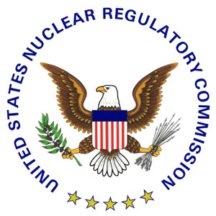 | NRC NEWS  U.S. NUCLEAR REGULATORY COMMISSION  Office of Public Affairs Telephone: 301/415-8200  Washington, D.C. 20555-0001  E-mail: opa.resource@nrc.gov  Site: http://www.nrc.gov
No. 09-200 | December 18, 2009

NRC SEEKS PARTICIPANTS FOR UPCOMING DISCUSSIONS
ON DRAFT SAFETY CULTURE POLICY

The Nuclear Regulatory Commission will host several public workshops next year to gather input on the agency’s draft policy statement on “safety culture,” and the staff wants to hear from individuals interested in participating in the workshops’ roundtable discussions.

“Safety culture is not a simple issue, but it is vital to the NRC’s mission of protecting the public’s health and safety,” said NRC Chairman Gregory B. Jaczko. “Public involvement is critical to addressing the complexities of this topic and I welcome and encourage the public’s participation in the upcoming discussions.”

The Commission recently published the draft safety culture policy statement in the Federal Register, (http://edocket.access.gpo.gov/2009/pdf/E9-26816.pdf ), setting forth the NRC’s expectation that all licensees and certificate holders establish and maintain a safety culture that protects public health and safety and the common defense and security. The draft policy defines safety culture as: “That assembly of characteristics, attitudes and behaviors in organizations and individuals which establishes that as an overriding priority, nuclear safety and security issues receive the attention warranted by their significance.”

The workshops, described in another Federal Register notice (http://edocket.access.gpo.gov/2009/pdf/E9-29793.pdf), are tentatively scheduled for February, April and October 2010. The staff expects the workshops will help forge a consensus around the objectives, strategies, activities and measures that enhance safety culture for NRC-regulated activities. The effort should also help develop high-level description/traits of areas important to safety culture. These concepts will be incorporated into the final safety culture policy statement and could also be incorporated into the NRC’s oversight programs.

Individuals or organizations interested in participating should submit names of individuals who will represent a group (or themselves) to Alex Sapountzis or Maria Schwartz, by mail to U.S. Nuclear Regulatory Commission, Office of Enforcement, Concerns Resolution Branch, Mail Stop O-4 A15A, Washington, DC 20555-0001, or by e-mail to Alexander.Sapountzis@nrc.gov or Maria.Schwartz@nrc.gov.

###

News releases are available through a free listserv subscription at the following Web address: http://www.nrc.gov/public-involve/listserver.html. The NRC homepage at www.nrc.gov also offers a SUBSCRIBE link. E-mail notifications are sent to subscribers when news releases are posted to NRC's Web site.

